Information centre of
the Federal Republic of Germany

ExpoMedical - International Show for Products, Equipment and Services for the Healthcare Sector
25. Sep. - 27. Sep. 2019, Buenos Aires, Argentina
 |  | Organiser | In cooperation with
Messe Düsseldorf GmbH  Messeplatz  40474 Dusseldorf  Germany |  | 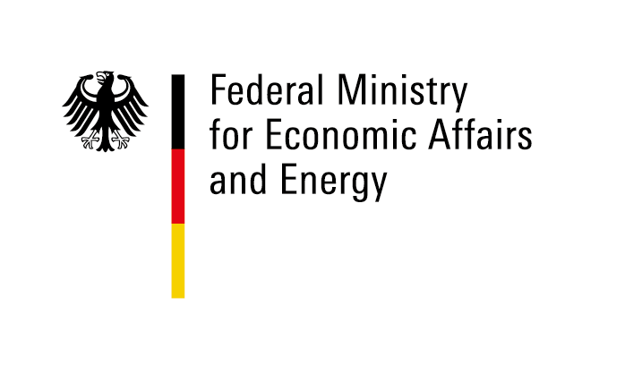 |  | 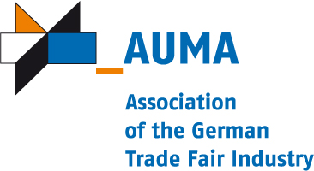
Realisation and exhibition management (implementation company
within the meaning of the General Conditions of Participation)
Messe Düsseldorf GmbH
http://www.messe-duesseldorf.de
 |  | Phone: +49 211 4560-01  Project manager:  Vanessa Klein / Udo Wiemann  KleinV@messe-duesseldorf.de /WiemannU@messe-duesseldorf.de  Phone: +49 211 4560-489 / 0211 4560-7756  Fax: +49 211 4560 87489 / 0211 4560-87-7756 |  |  | 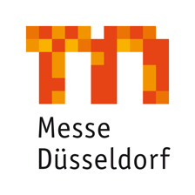
Registration | Closing date for registrations: 24. May 2019
We hereby register as participants at the above-mentioned participation.

1. Participant
 | Company name:
 | Street: |  | Contact partner:
 | Postcode & town: |  | Phone:
 | Federal state: |  | Fax:
 | VAT ID: |  | E-Mail:

2. Required exhibition space and mandatory fee/s
All amounts indicated below are subject, where applicable, to statutory German and to statutory foreign taxation
2.1. Participation up to and including the 4th time:
à EURO 675,00 / participant
2.2. Participation for the 5th time or more:
• not applicable
2.3. Participation of exhibitors, which cannot sign the attached declaration regarding double-funding respectively participation of the public sector (public authorities or public companies):
à EURO 2.040,00 / participant
3. Mandatory fee/s
• not applicable
4. Exhibition goods (At information stand: product range) Dimensions Weight
•
•
•
We have noted and acknowledged the General and Special Conditions of Participation. We undertake only to exhibit products which are produced according to No. 8 of the General Conditions for Participations of the Federal Republic of Germany at trade fairs and exhibitions abroad. We have completed and enclosed the registration appendices. We agree to the computer-aided recording, storage, and forwarding of company details to third parties. We declare, that insolvency proceedings have not been filed or opened for our assets or that we have not issued or are obliged to make a statutory declartion in accordance with sec. 802c Civil Code of Civil Procedure (ZPO) or sec. 384 of the German Tax Code (AO) 1977.

Place, date | Company stamp & legally binding signature
Enclosures:
• Appendix to registration form: Special Conditions of Participation
• Appendix to registration form: General Conditions of Participation
• Appendix to registration form: Declaration regarding double-funding resepectively participation of the public sector

Information centre of the Federal Republic of Germany

ExpoMedical - International Show for Products, Equipment and Services for the Healthcare Sector
25. Sep. - 27. Sep. 2019, Buenos Aires, Argentina

Appendix to registration form
(Mandatory: please return with the registration form)

Exhibitor
 | Company:
 | Street: |  | Managing Director:
 | ZipCode, Town: |  | Commercial Reg.-No.:
 | Federal state: |  | District court:
 |  |  | Contact partner:

Declaration regarding double-funding respectively participation of the public sector
(public authorities or public companies)
With our registration for the Information centre of the Federal Republic of Germany at the

ExpoMedical - International Show for Products, Equipment and Services for the Healthcare Sector
25. Sep. - 27. Sep. 2019, Buenos Aires

I hereby declare/we hereby declare, that I/we do not receive any institutional fundings granted/covered by public resources.
I hereby declare/we hereby declare, that I/we do not receive any further public support out of project fundings for the participation at this trade fair/exhibition.
I hereby declare/we hereby declare, that my/our company is not a federal, state or municipal authority, is neither a state development institution nor a any other legal entity under public law.
I hereby declare/we hereby declare that my/our company is not directly or indirectly majority-owned by a religious community/communities or by a legal entity/entities under public law.

Place, Date | Company stamp & legally binding signature

